

**YEAR: 12**

**GENERAL BIOLOGY**

**Test 2 : Inheritance and Change**

**Please do not mark this paper.**

MULTIPLE CHOICE (15 marks)

1. What are the components of DNA?

a) Sugars, bases, proteins

b) Sugars, phosphates, bases

c) Phosphates, bases, polypeptides

d) Phosphates, proteins, polypeptides

2) The sex of an individual is determined when the

1. egg is formed
2. sperm is formed
3. egg is fertilised by the sperm
4. embryo is 12 weeks old
5. If a mutation occurs in an individual, it can only be passed onto the next generation if it
   1. Is a mutation of the somatic cells

b) Occurs in the gametes producing offspring

1. Is a change in the X or Y chromosomes
2. Is caused by environmental factors
   * 1. Generally, gametes produced by an organism will not be identical. Which of the following does NOT influence this genetic variability of gamete formation?

a) Mutation

b) Sex linkage

c) Independent assortment of alleles

d) Crossing over in homologous chromosomes

* + 1. An important benefit of sexual reproduction in natural selection is that

1. It provides for a mechanism for genetic recombination, providing variations in offspring
2. It requires less energy than asexual reproduction so that the organisms survive and reproduce at a greater rate
3. The offspring survival rate is greater than for asexual reproduction
4. The offspring require the same conditions for survival as the parents
   * 1. Which of the following statements about mutations is FALSE?
5. Mutations can occur in any cell that contains DNA
6. Mutations can be inherited
7. Any change in a DNA sequence is called a mutation
8. A mutation always has a damaging effect on cells
   * 1. Selection pressure acts directly on
9. The phenotype of an individual
10. The genotype of an individual
11. The entire genome
12. The population gene pool
    * 1. One of the biggest ways that a species evolves is because some organisms with some traits survive and reproduce better than others. This process is known as
    1. natural selection
    2. convergent evolution
    3. coevolution
    4. sexual selection
       1. Genes for traits that help an organism be more successful reproductively can be expected to
13. cause it to evolve into a new species
14. become more common in the future
15. cause the extinction of the species
16. eventually be eliminated by natural selection
    * 1. Individuals that are well adapted to their environment will survive and produce
17. fewer mutations
18. more offspring
19. stronger genes
20. better traits

**Year 12**

**General Biology**

|  |
| --- |
| Name: |
| Teacher: |

|  |  |  |  |
| --- | --- | --- | --- |
| **Task 6: Inheritance and Change Test** | | | Weighting 7.5% |
| Marks Received | Marks Available | Percentage | |
|  | 38 |  | |

Time Allocated:

Working time: 50 minutes

**Multiple Choice Short Answer Extended Answer Total**

**/23**

**/10**

**/5**

**/38**



**TEST: Inheritance and Change**

**ANSWER BOOKLET**

**NAME:**

**FORM:** **DATE:**

**SECTION ONE:** Multiple choice answers

Cross (X) through the correct answer.

|  |  |  |  |  |
| --- | --- | --- | --- | --- |
| 1 | a | b | c | d |
| 2 | a | b | c | d |
| 3 | a | b | c | d |
| 4 | a | b | c | d |
| 5 | a | b | c | d |
| 6 | a | b | c | d |
| 7 | a | b | c | d |
| 8 | a | b | c | d |
| 9 | a | b | c | d |
| 10 | a | b | c | d |

**Short Answer Section (23 marks)**

* + 1. The diagram below is of genetic information and where it can be found. (4marks)

1. Add the following labels to the diagram

Cell Chromosome DNA Genes Nucleus

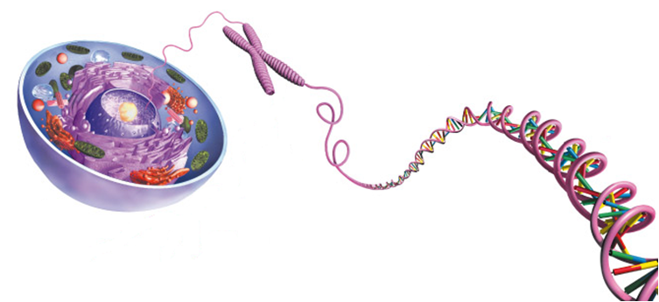

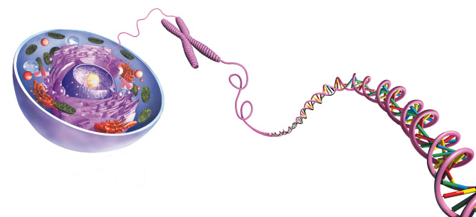

b. Name the complementary base pair for the following nitrogen bases:

Adenine _____________________________

Guanine _____________________________

c. DNA stands for _______________________________________

* + 1. a. Define Mutation (2marks)

_____________________________________________________________________________

_____________________________________________________________________________

_____________________________________________________________________________

_____________________________________________________________________________

b. List two differences between somatic and germline mutations. (2marks)

_____________________________________________________________________________

_____________________________________________________________________________

_____________________________________________________________________________

_____________________________________________________________________________

* + 1. Distinguish between gene and chromosomal mutations. (3 marks)

_____________________________________________________________________________

_____________________________________________________________________________

_____________________________________________________________________________

_____________________________________________________________________________

* + 1. Give the name of and explain one type of mutation that can affect a gene AND a chromosome (4marks)

Gene:

_____________________________________________________________________

_____________________________________________________________________________

_____________________________________________________________________________

Chromosome:

_____________________________________________________________________________

_____________________________________________________________________________

_____________________________________________________________________________

* + 1. Give an example of one gene and one chromosomal mutation which cause inheritable disease. (2 marks)

Gene:

_____________________________________________________________________________

_____________________________________________________________________________

_____________________________________________________________________________

Chromosome:

_____________________________________________________________________________

_____________________________________________________________________________

_____________________________________________________________________________

* + 1. Male peafowl, called peacocks, have long, colourful tail feathers. Among peacocks there is variation in the size, brightness, and pattern of the tail. Scientists observed the mating success of two groups of peacocks. The graph below shows the scientists’ data.

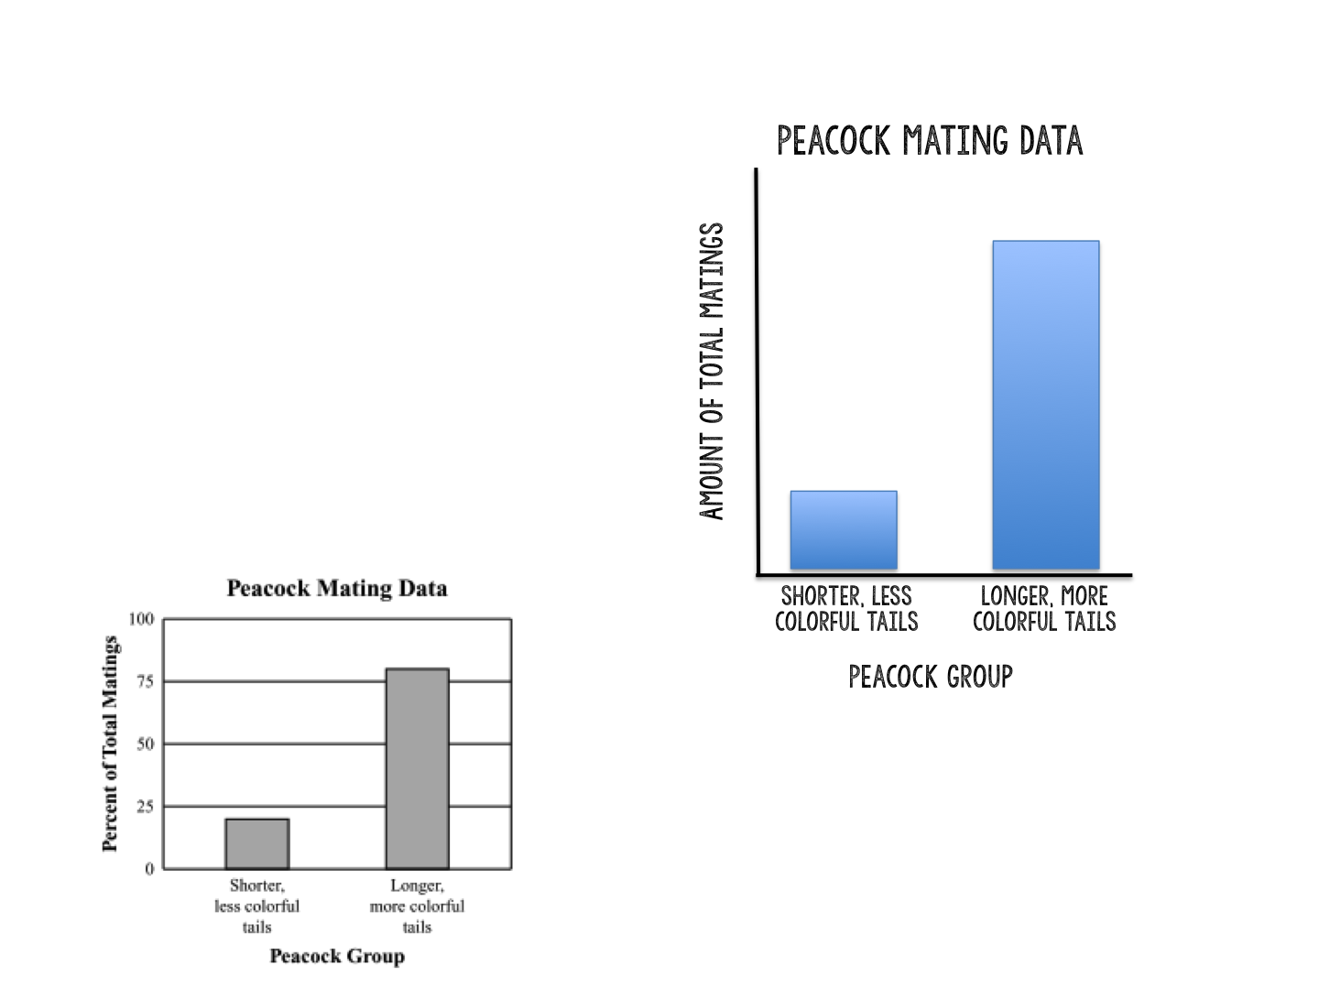

* 1. State what the graph shows about the advantage of longer, more colourful tails for peacocks. (1 mark)

_____________________________________________________________________________

_____________________________________________________________________________

* 1. Identify **one** disadvantage that longer, more colourful tails may have for peacocks.

(1 mark)

_____________________________________________________________________________

_____________________________________________________________________________

* 1. Explain how you think the longer, more colourful tails evolved in peacocks despite causing disadvantages for the males, based on what we’ve learned about evolution. (4 marks)

_____________________________________________________________________________

_____________________________________________________________________________

_____________________________________________________________________________

_____________________________________________________________________________

_____________________________________________________________________________

Extended Response (5 marks)

* + 1. A forest has many trees and bushes that produce nuts. This is a major food source for many species, include a particular bird. Birds of this species have a variety in beak shapes ranging from long and pointy to short and hard. The birds with short and hard beaks are able to eat the nuts better than the birds with long and pointy beaks.

What do you expect to happen to this population of birds over time, in terms of what you know about evolution? Address all principles of natural selection in your explanation.

_____________________________________________________________________________

_____________________________________________________________________________

_____________________________________________________________________________

_____________________________________________________________________________

_____________________________________________________________________________

_____________________________________________________________________________

_____________________________________________________________________________

_____________________________________________________________________________

_____________________________________________________________________________

_____________________________________________________________________________

_____________________________________________________________________________

_____________________________________________________________________________

_____________________________________________________________________________

_____________________________________________________________________________

_____________________________________________________________________________

_____________________________________________________________________________

_____________________________________________________________________________

_____________________________________________________________________________

_____________________________________________________________________________

_____________________________________________________________________________

_____________________________________________________________________________